OA Geoduck ImageJ Measurements

1. **Set scale at 1mm**

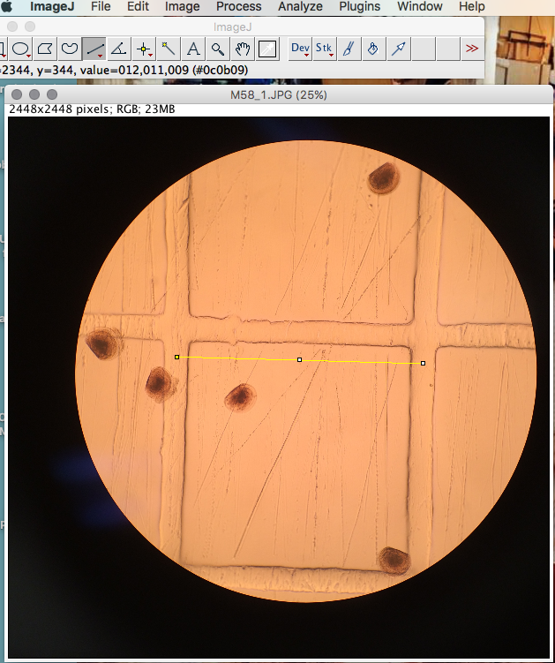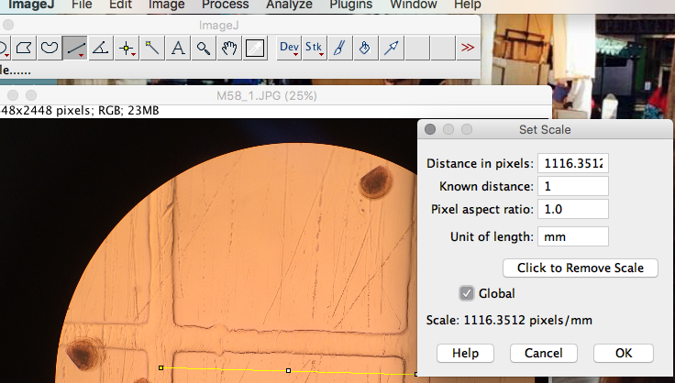

- Measuring from middle of gap to the middle of the opposite side (Analyze —> set scale —> 1 mm —> “Global”)

1. **Stamp individual larvae** (command D) using “M##_L##” where “M##” is the tube label, and “L##” is the larva number

- Within a tube (“M##”), measure 20 larvae (labels should be M##_L1 through M##_L20)

3. **Measure** length, width, and area for each larva in that order every time

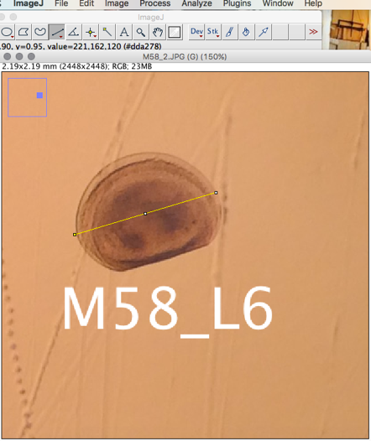 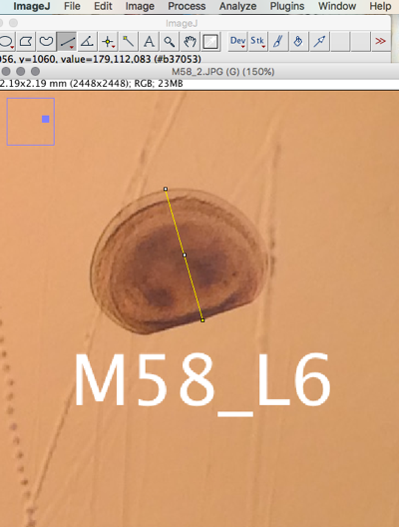 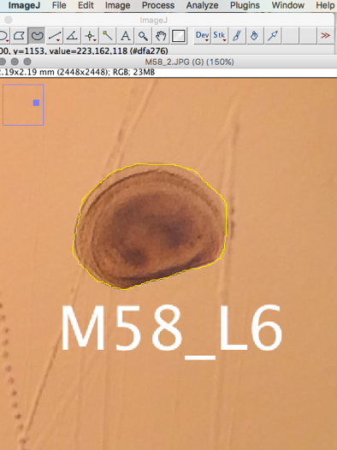

Length Width Area

1. **Copy results** into google sheet and then reorganize the raw data into a usable format. Never type data 🡪 ALWAYS COPY AND PASTE – less chance of human error

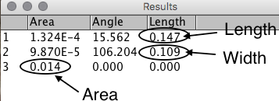

* 1. In this case, each larva will have three rows of results for data. The first row is the length, second row is the width, and third row is the area
  2. Because for each tube, we’ll be measuring 20 larvae, if 20 larvae are present, the results rows should end at 60.

1. **With each new image**, either reset scale or measure scale (remember to delete the measurement from the “Results” window after it is recorded on a spreadsheet) in order to calculate the coefficient of variation across images within tubes, and also between tubes.
2. **Save images as .tif**. Labeling as “M##_L##toL##” where M## is the tube ID, and “L##toL##” is the range of larvae in that image
3. **Copy data into .csv file** in google drive that is being used with RStudio
4. **Upload labeled .tif** images to [Google Drive folder](https://drive.google.com/open?id=0B_Kednl1tNImY0I3MzVnVE03QW8)